**Subject:** Database Systems

**Subject Code**: CPSC 50900 -004 (on campus)

**Semester:** Fall 2023

**Project Title:** Shelter for Stray dogs

**Name:** Smitesh Raj

**GitHub URL:** https://github.com/Dante1096

**SQL environment:** Windows

**Week 1:**

Company Name: StrayHaven Shelter Solutions, Inc.

Business Description: StrayHaven Shelter Solutions, Inc. is a non-profit organization dedicated to providing comfortable shelter options for stray dogs using eco-friendly and locally sourced materials.

Supply Chain:

1. Recycled Plastic

- Raw Materials: Recycled plastic.

- Sources:

1. Local Recycling Centers: We collect plastic materials from nearby recycling centers.

2. Donations: Local businesses and individuals donate plastic waste for shelter construction.

2. Bedding

- Raw Materials: Reused blankets, pillows, and cushions.

- Sources:

1. Local Donations: We gather discarded bedding materials from local donations.

2. Secondhand Stores: We purchase used bedding items from charity shops.

3. Natural Light

- Raw Materials: Large windows and eco-friendly heating.

- Sources:

1. Local Suppliers: We source large windows and glass from local suppliers. Also, people who want to help with this project donate this material.

2. Solar Design: Our shelters are designed to harness natural sunlight and heat through their structure.

Primary Office and Operating Cities:

- Primary Office: Our main office is located on the empty ground behind Lewis University near the airport.

- Operating Cities: We serve multiple regions in Illinois, focusing on regions with high numbers of stray dogs, including Chicago, Naperville, Romeoville, etc.

**PART 2:**

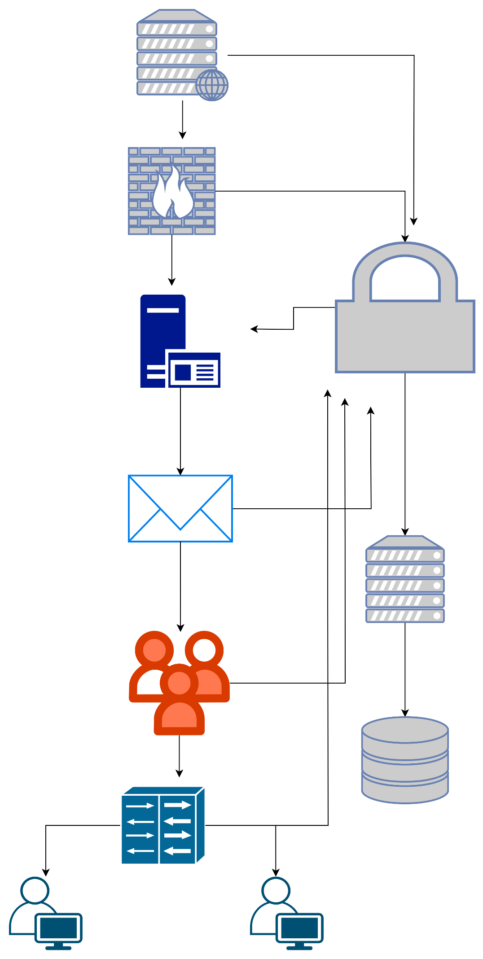

**Week 2:**

1. List 5 entities and provide a short description of each to identify what they are:

1)Shelter

Capacity (integer) - The maximum number of stray dogs the shelter can accommodate.

Location (character) - The geographical location of the shelter.

Construction Material (character) - The type of eco-friendly materials used in the shelter.

2) Recycled Plastic Source

Source Name (character) - The name of the recycling center or donor.

Material Type (character) - Indicates whether the source provides recycled plastic materials.

Quantity Donated (integer) - The amount of recycled plastic donated.

3) Bedding Source

Bedding Source Name (character) - The name of the donation center or secondhand store.

Bedding Material Type (character) - Indicates whether the source provides bedding materials.

Quantity of Bedding Donated (integer) - The amount of bedding materials donated.

4) Natural Light

Shelter Name (character) - The name or identifier of the shelter.

Window Supplier Name (character) - The name of the local supplier or donor providing windows.

Solar Design Availability (boolean) - Indicates whether the shelter is designed to harness natural sunlight and heat (true or false).

5) Volunteer

Volunteer Name (character) - The name of the individual volunteering with the organization.

Contact number (integer) - Contact detail such as phone number

Volunteer Role (character) - The specific role or task the volunteer is assigned within the organization.

**Github:** [**https://github.com/Dante1096**](https://github.com/Dante1096)

**CSV1 Shelter:**

<?xml version="1.0" encoding="UTF-8"?>

<root>

<row>

<Shelter></Shelter>

<FIELD2></FIELD2>

</row>

<row>

<Shelter>Capacity</Shelter>

<FIELD2>Integer</FIELD2>

</row>

<row>

<Shelter>Location</Shelter>

<FIELD2>string</FIELD2>

</row>

<row>

<Shelter>Contruction material</Shelter>

<FIELD2>string</FIELD2>

</row>

</root>

**CSV2 recycled plastic:**

<?xml version="1.0" encoding="UTF-8"?>

<root>

<row>

<Recycled Plastic Source></Recycled Plastic Source>

<FIELD2></FIELD2>

</row>

<row>

<Recycled Plastic Source>Source Name </Recycled Plastic Source>

<FIELD2>string </FIELD2>

</row>

<row>

<Recycled Plastic Source>Material Type </Recycled Plastic Source>

<FIELD2>string </FIELD2>

</row>

<row>

<Recycled Plastic Source>Quantity Donated </Recycled Plastic Source>

<FIELD2>integer</FIELD2>

</row>

</root>

**CSV3 bedding:**

<?xml version="1.0" encoding="UTF-8"?>

<root>

<row>

<Bedding Source></Bedding Source>

<FIELD2></FIELD2>

</row>

<row>

<Bedding Source>Bedding Source Name </Bedding Source>

<FIELD2>string</FIELD2>

</row>

<row>

<Bedding Source>Bedding Material Type </Bedding Source>

<FIELD2>string</FIELD2>

</row>

<row>

<Bedding Source>Quantity of Bedding Donated </Bedding Source>

<FIELD2>integer</FIELD2>

</row>

</root>

**CSV4 Natural light:**

<?xml version="1.0" encoding="UTF-8"?>

<root>

<row>

<Natural light></Natural light>

<FIELD2></FIELD2>

</row>

<row>

<Natural light>Shelter Name</Natural light>

<FIELD2>string</FIELD2>

</row>

<row>

<Natural light>Window supplier name</Natural light>

<FIELD2>string</FIELD2>

</row>

<row>

<Natural light>Solar design availability</Natural light>

<FIELD2>boolean</FIELD2>

</row>

</root>

**CSV5 volunteers**

<?xml version="1.0" encoding="UTF-8"?>

<root>

<row>

<Volunteer></Volunteer>

<FIELD2></FIELD2>

</row>

<row>

<Volunteer>Volunteer Name </Volunteer>

<FIELD2>string</FIELD2>

</row>

<row>

<Volunteer>Contact number </Volunteer>

<FIELD2>integer</FIELD2>

</row>

<row>

<Volunteer>Volunteer Role </Volunteer>

<FIELD2>string</FIELD2>

</row>

</root>

**Week 3:**

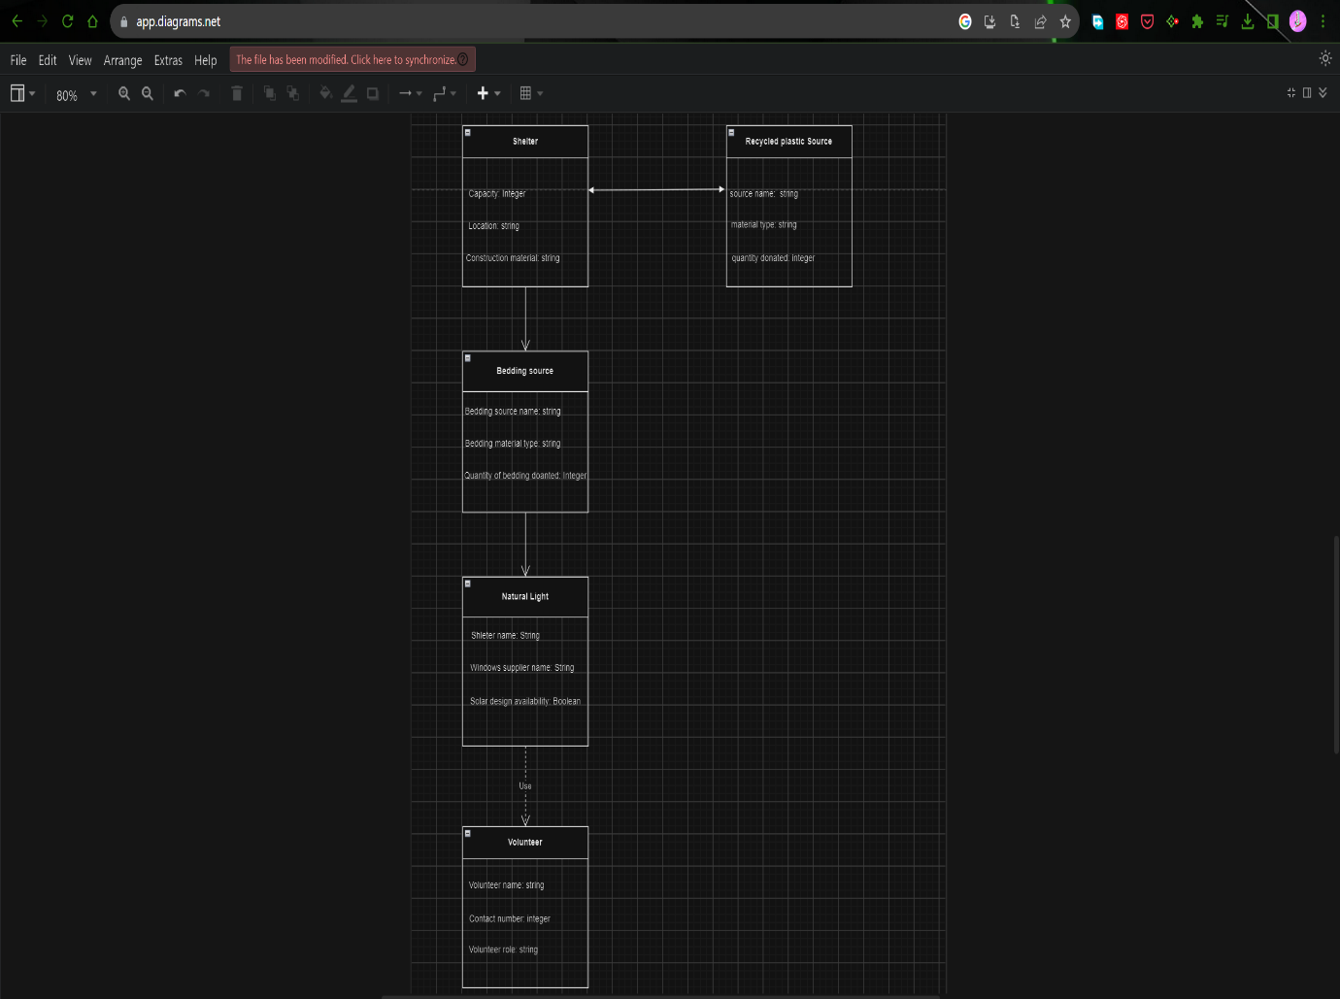

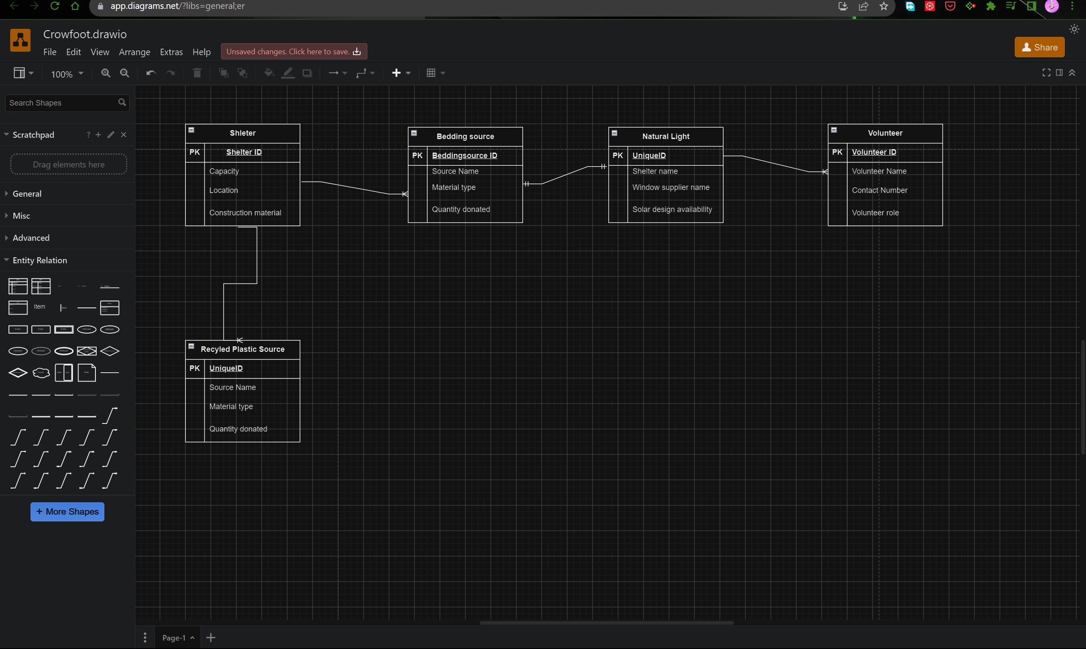

**Relationships between the entities:**

Shelter and Recycled Plastic Source

- Relationship: One-to-Many

- Explanation: One shelter can receive donations from many recycled plastic sources, but each recycled plastic source is associated with only one shelter.

Shelter and Bedding Source:

- Relationship: One-to-Many

- Explanation: Similar to the Recycled Plastic Source relationship, one shelter can receive donations from multiple bedding sources, but each bedding source is associated with only one shelter.

Shelter and Natural Light:

- Relationship: One-to-One

- Explanation: each shelter has a unique natural light setup, it's a one-to-one relationship.

Shelter and Volunteer:

- Relationship: One-to-Many

- Explanation: A shelter can have many volunteers, but each volunteer is associated with only one shelter.

**Week 4:**

Script:

-- ## PART A

-- # Create tables

create table shelter(capacity int, location varchar(100), constructionmaterial varchar(255))

create table bedding(sourcename varchar(100), materialtype varchar(100), quantitydonated int)

create table naturallight(sheltername varchar(100),windowsupplier varchar(100),solaravailability boolean)

create table recycledplastic(sourcename varchar(100), materialtype varchar(100), quantitydonated int)

create table volunteer(name varchar(30), contactnumber int, role varchar(20));

-- LOAD FILES TO MySQL

LOAD DATA LOCAL INFILE './Desktop/temp/shelter.csv' INTO TABLE shelter FIELDS TERMINATED BY ',' LINES TERMINATED BY '\n' IGNORE 1 LINES;

LOAD DATA LOCAL INFILE './Desktop/temp/bedding.csv' INTO TABLE shelter FIELDS TERMINATED BY ',' LINES TERMINATED BY '\n' IGNORE 1 LINES;

LOAD DATA LOCAL INFILE './Desktop/temp/naturallight.csv' INTO TABLE shelter FIELDS TERMINATED BY ',' LINES TERMINATED BY '\n' IGNORE 1 LINES;

LOAD DATA LOCAL INFILE './Desktop/temp/recycledplastic.csv' INTO TABLE shelter FIELDS TERMINATED BY ',' LINES TERMINATED BY '\n' IGNORE 1 LINES;

LOAD DATA LOCAL INFILE './Desktop/temp/volunteerI.csv' INTO TABLE shelter FIELDS TERMINATED BY ',' LINES TERMINATED BY '\n' IGNORE 1 LINES;

-- ## PART 4B

-- # (i) insert values in bedding and recycledplastic table

INSERT INTO bedding()values('New LTD','Metalics',30);

INSERT INTO recycledplastic()values('New Doner','plastic Drums',30);

-- # (ii) update the column with the quantity of 40 and set its value to n' New Edited Plastic

update recycledplastic set materialtype='New Edited Plastic' where quantitydonated = 40;

update bedding set quantitydonated=3000 where sourcename='Frienders'; -- update bedding table

-- # (iii)

select * from bedding where quantitydonated = 30; -- return columns in table bedding with quantity value of 30

select name from volunteer; -- Select and display a name column only

-- #(iv) Join tables

-- Join shelter and naturallight tables using shelterid

SELECT capacity, location, windowsupplier from shelter inner join naturallight ON shelter.shelterid = naturallight.shelterid;

SELECT R.materialtype AS RMaterial, R.quantitydonated AS quantity, B.sourcename FROM recycledplastic R INNER JOIN bedding ON R.sourcename=B.sourcename;

-- #(v) summary functions

SELECT COUNT(*) AS total_data from bedding; -- count the number of rows in bedding table

SELECT SUM(quantiydonated) AS total_quantity_donated from bedding; -- return the total of quantitydonated in wedding table

SELECT (SUM(S.quantitydonated)+SUM(R.quantitydonated)) AS total from bedding S JOIN recycledplastic R;

**Screenshots:**

PART A

CREATE DATABASE

The first step is to create a database to store the tables.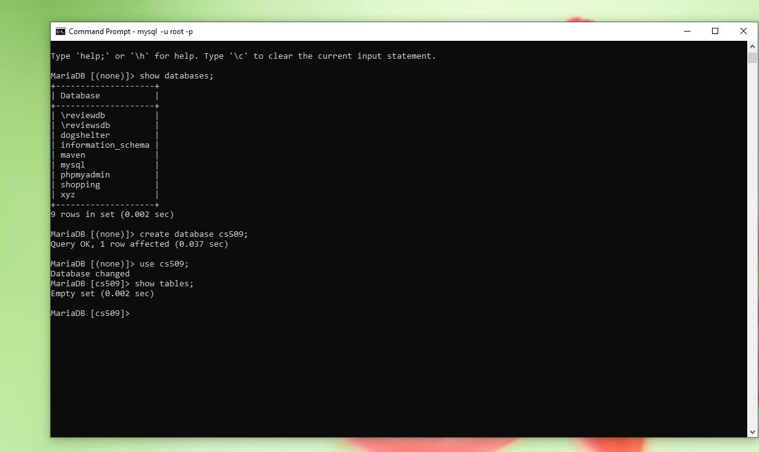

The screen below show empty tables, bedding, volunteer and naturallight.

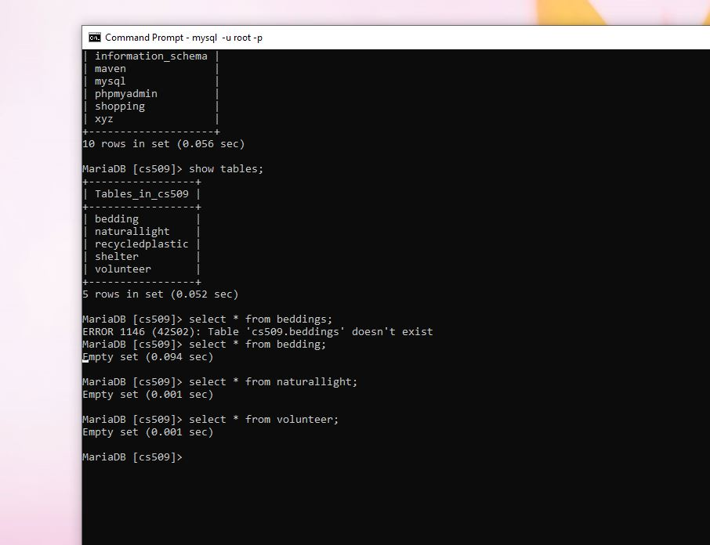

Export data to mysql

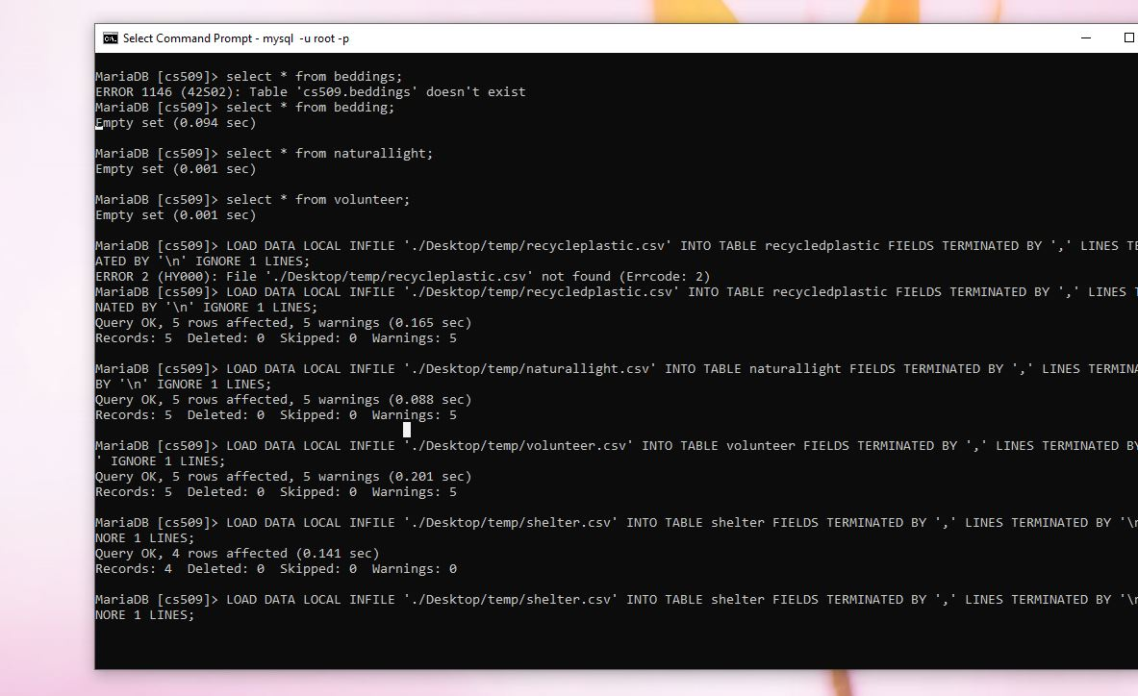

Displaying the result after loading data to MySQL

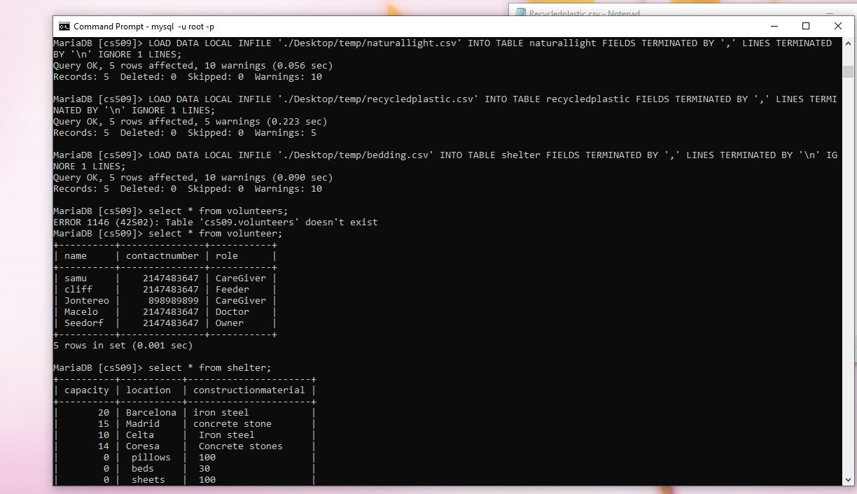

PART B

Insert statements

The first statement insert a new record to the bedding table and the second in the recycledplastic table;

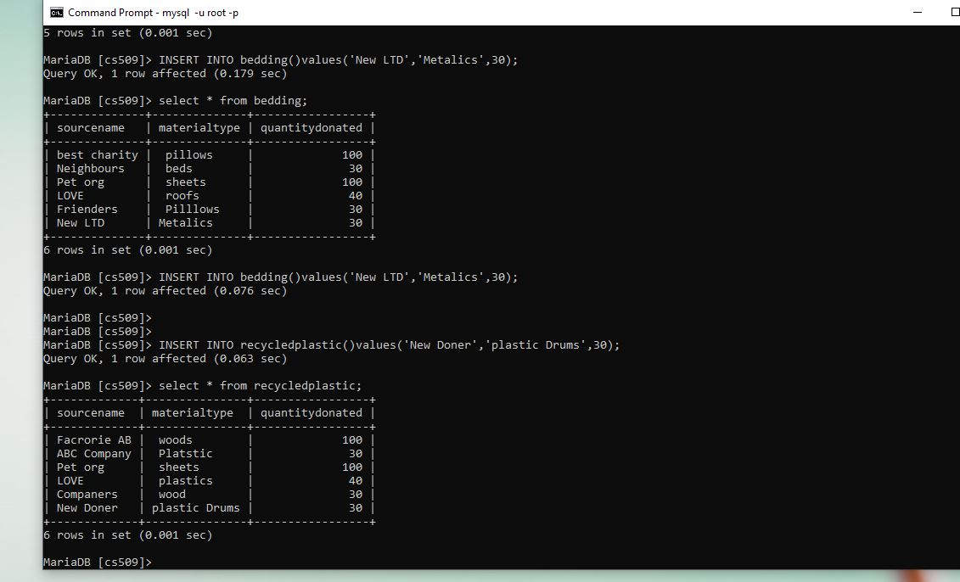

Next, we update the content in our database. I have made two queries and showed the result at the bottom.

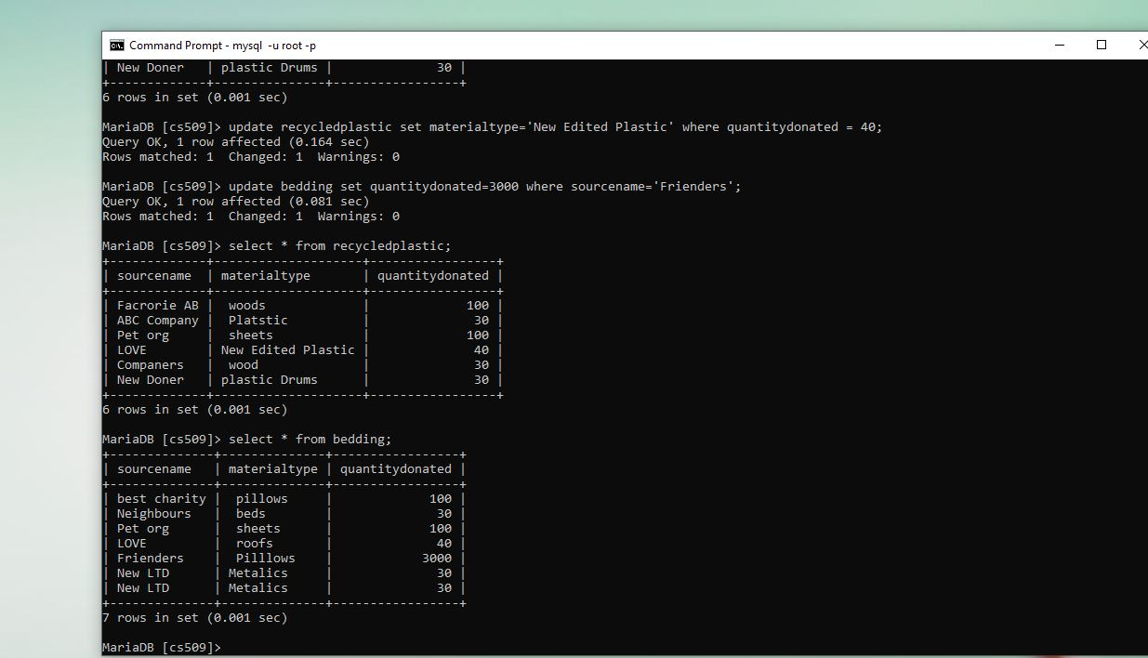

Using select statement to select content from the database. The first scenario we are getting all columns and rows while in the second scenario we only display the name column.

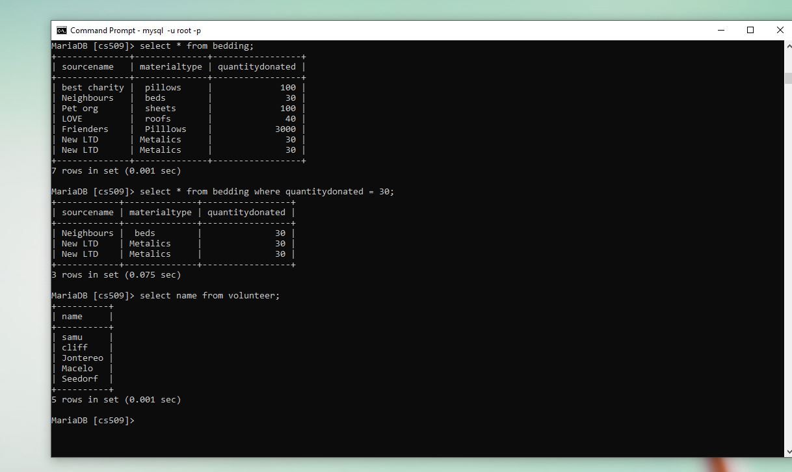

Using join to merge two tables

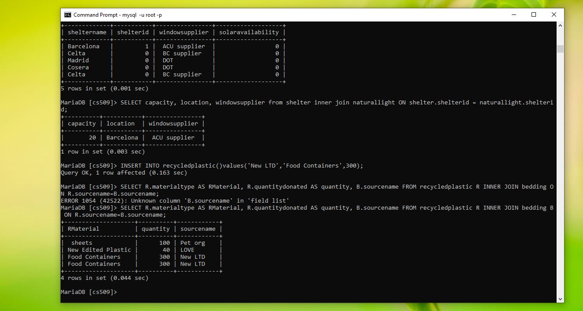

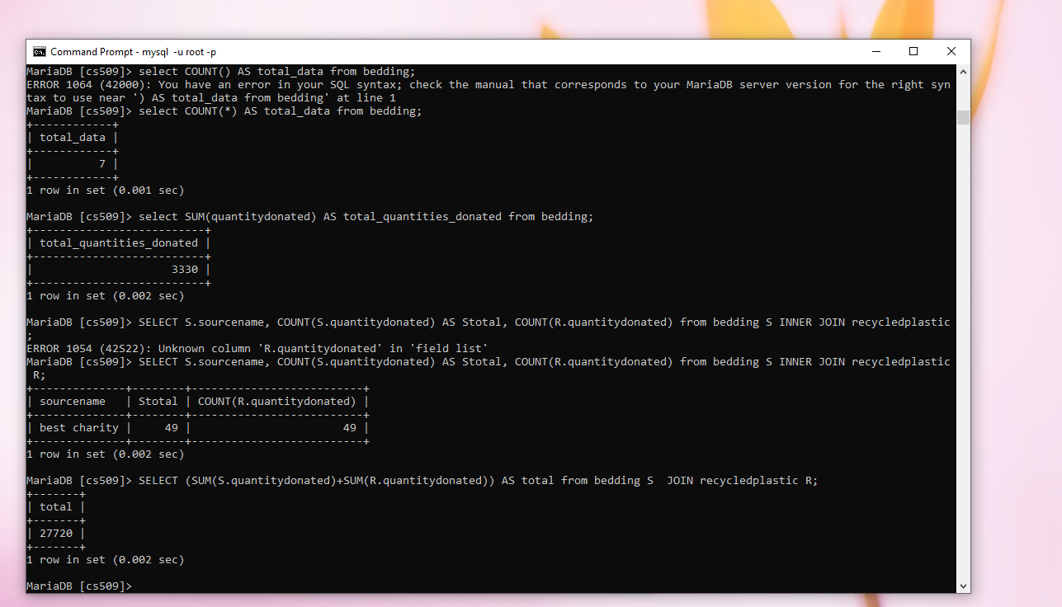

Deleting item from shelter table

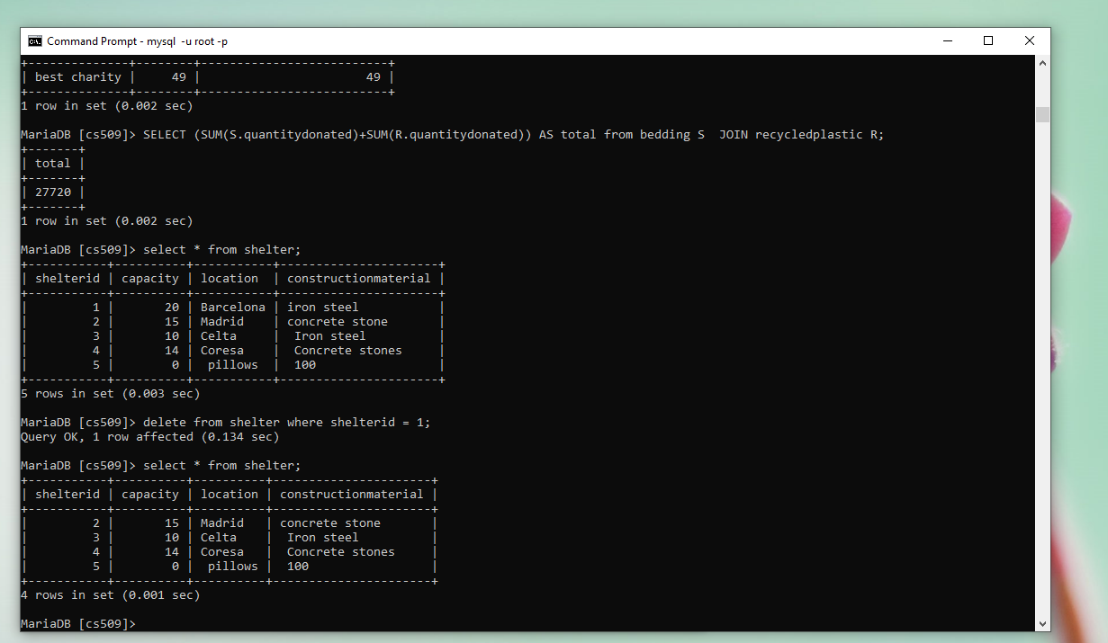

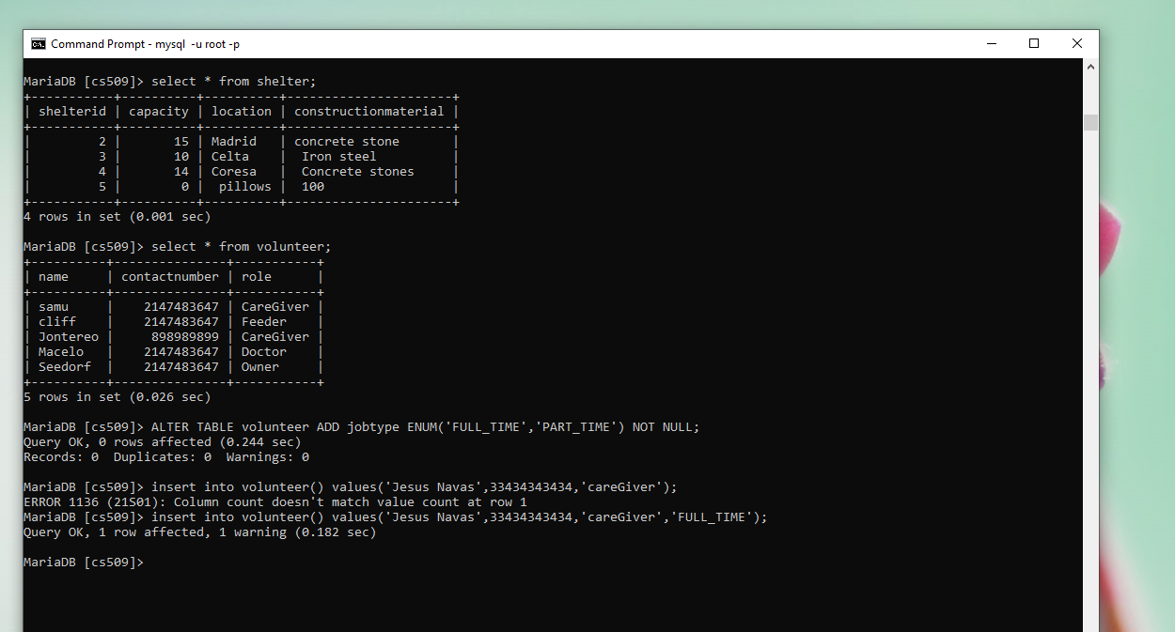

Deleting the new added user.

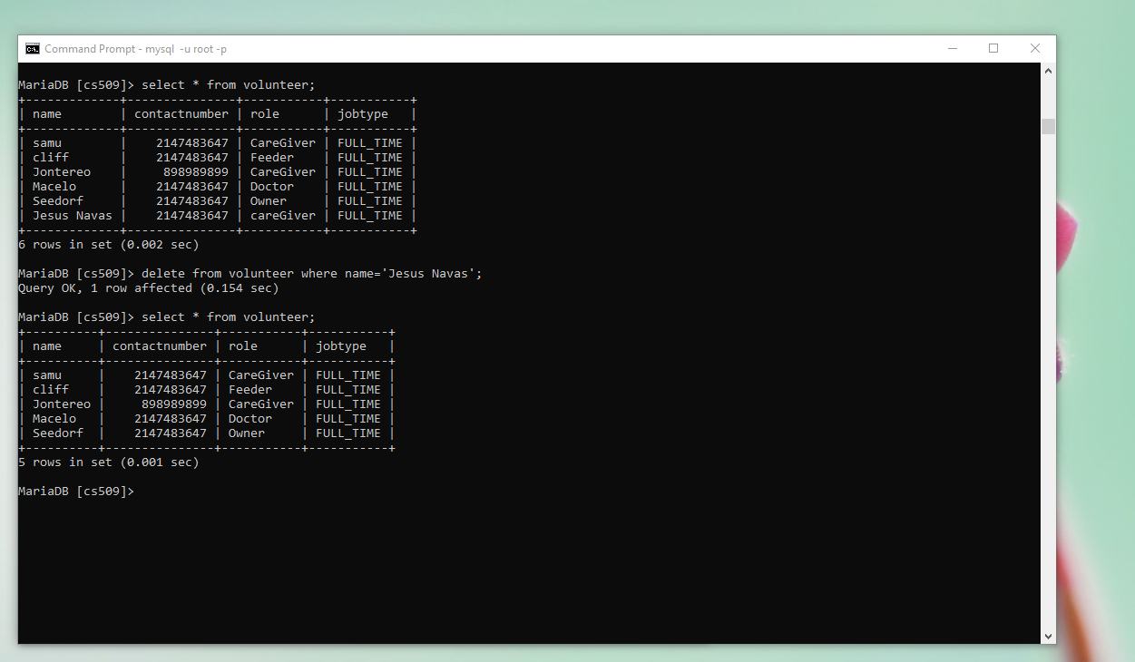

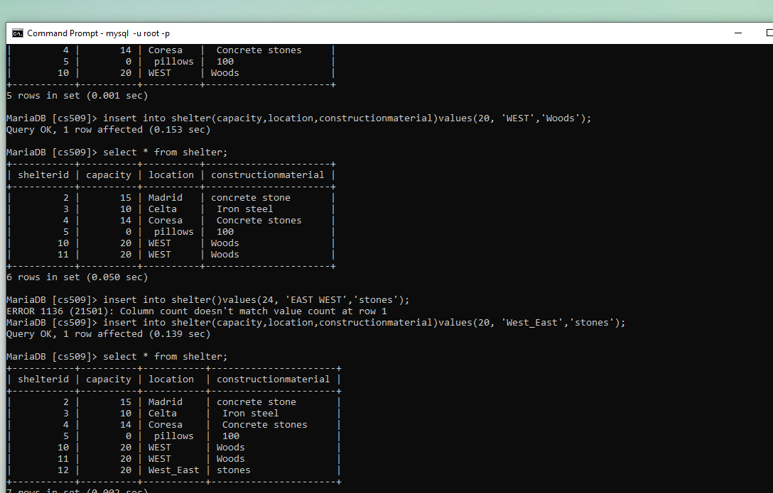

Create a new column in the shelter table and give it a default color black.

